Conceptual Design of a Greedy Cup Molten Salt or ULIMES Fueled Reactor
This document updates the conceptual advanced nuclear reactor design incorporating molten salt or Uranium Dioxide Liquid Metal Suspension (ULIMES) fuel, with a separate lead or lead-bismuth eutectic (LBE) coolant. Key refinements include exclusive use of lead or LBE coolant with natural circulation in both fuel and coolant loops (no pumps), elimination of any sodium coolant to avoid fire risks, a closed Brayton cycle using supercritical CO₂ or nitrogen as the working gas for power generation, and strict separation of any water-based combined cycle elements far from the molten lead areas. The greedy cup siphon mechanism is retained for passive emergency drainage, replacing freeze plugs and integrated with ECCS for level raising and reactivity quenching. No pumps or freeze plugs. Overheating results in siphoning of fuel.
The mixed neutron spectrum core features a central thermal zone with carbon or beryllium carbide solid moderators, an epithermal fuel region without solid moderators, and a thorium blanket using molten thorium salt or dissolved ThO₂ in liquid metal, arranged in hexagonal close-packed (HCP) geometry in the epithermal and blanket regions.
This writeup is released into the public domain, free for use, modification, and distribution without restriction.
Introduction
This revision focuses on passive safety and material compatibility, using lead or LBE coolant for its high boiling point, low reactivity, and natural circulation advantages without pumps. The power conversion employs a closed Brayton cycle with supercritical CO₂ or nitrogen, achieving high efficiency (>40%) at outlet temperatures of 650-700°C. Water is only introduced post-turbine in a distant combined cycle setup for additional efficiency, ensuring no interaction with molten lead or salt to prevent explosions or corrosion. The greedy cup provides reliable passive drainage, distinct from freeze plugs which can refreeze or fail.
Multiple siphons with larger diameter in separated loops assure that should a line freeze or should the heavy coolant intrude, the other siphons will drain to independent flat storage tanks.
The design targets 150+ MWe, with thorium breeding for sustainability and minimal waste.
Core Design
The cylindrical core (~3-4 m diameter, 4-5 m height) maintains radial zoning: central thermal (~30% radius) with solid carbon or Be₂C moderators, middle epithermal (~40%) unmoderated fuel channels, and outer blanket (~30%) thorium material in HCP lattice (pitch ~15-20 cm). Inert gas overhead (helium or argon) equalizes pressure with the catch tank.
Reactivity control relies on negative coefficients and ECCS absorber injections, minimizing or eliminating traditional control rods.
Fuel and Coolant Systems
- Fuel Loop: Molten salt (e.g., FLiBe-UF₄) or ULIMES (UO₂ in Bi-Pb-Sn) circulates naturally via buoyancy: hot fuel rises through core channels to elevated intermediate heat exchangers (5-10 m above core), cools by transferring heat to coolant, and descends via downcomers. No pumps; flow driven by density differences.
- Coolant Loop: Lead or LBE coolant in a separate natural circulation circuit: absorbs heat from fuel in elevated intermediate exchangers, rises to secondary heat exchangers, rejects heat to the Brayton cycle gas, and descends. No pumps, leveraging lead's high density for strong thermosiphon effect. LBE preferred for lower melting point (~125°C).
- Power Cycle: Closed Brayton cycle with supercritical CO₂ or nitrogen as working gas. Heat from coolant superheats the gas, driving a turbine-generator. For combined cycle enhancement, exhaust gas heat recovers to a steam Rankine cycle, but water systems are physically isolated (>100 m away) from reactor components to eliminate risks.
- Ultimate Heat Sink: Passive air cooling via finned radiators or chimneys, activated by valve opening in emergencies. No water near reactor.
Gravity-fed fueling from elevated reservoirs supports online refueling via controlled greedy cup activation.
Safety Features
- Greedy Cup Mechanism: Inverted siphon in core plenum drains fuel to subcritical catch tank when level rises above bend, triggered by ECCS. No freeze plugs; this passive overfill system is more reliable.
- ECCS System: Gravity injection of solid or liquid molten salt with neutron absorbers (e.g., GdF₃). Raises core level for drainage while quenching fission. Doubles for reactivity control.
- Natural Circulation: Both loops pump-free, with elevation providing ~10-20 kPa head for stable flow.
- No Sodium or Water Risks: Lead/LBE inertness avoids fires; water isolation prevents interactions.
- Gas Overhead: Ensures pressure balance for smooth operation and drainage.
Operational Parameters
Power density: 100-200 kW/L; outlet temperature: 650-700°C; breeding ratio: 1.05-1.1; flow velocity: 0.5-1 m/s. Cycle efficiency: 45-50% with Brayton + combined.
Conceptual Drawings
Drawings emphasize lead/LBE natural circulation without pumps, greedy cup, and Brayton cycle.
- Greedy Cup and ECCS Integration (ASCII Art):
text
Normal: Emergency:
_______________ _______________
| Gas Overhead | | Gas Overhead |
|______________| |______________|
| Fuel Level | | Raised Level | <-- ECCS Injection
| (Below Bend) | | (Over Bend) |
| Core | | Core |
|______________| |______________|
| |
| Siphon Bend | Activated Siphon
v v
No Drainage Drainage to Catch (No Freeze Plug)

(Diagram of closed Brayton cycle with supercritical CO₂ for nuclear heat, adaptable to nitrogen.)
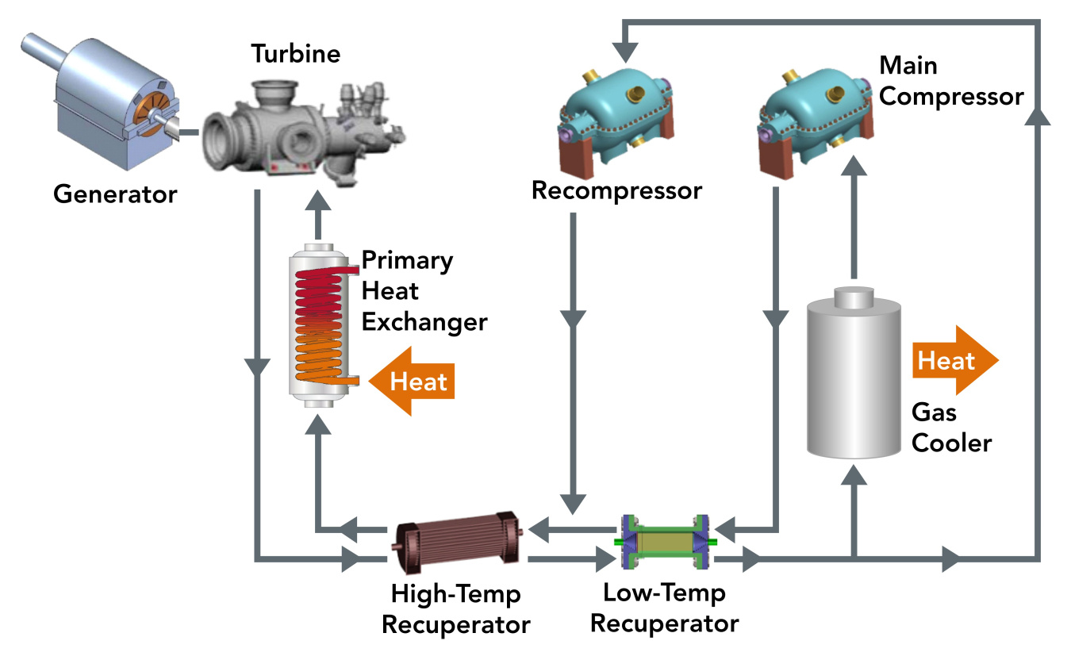
energy.gov
sCO2 Power Cycles for Nuclear | Department of Energy
Consultations on Refinements
- Pump Elimination: Validate natural circulation in lead/LBE via CFD; lead's density enhances flow, but optimize elevations.
- Gas Choice: Supercritical CO₂ for efficiency; nitrogen for simplicity. Test compatibility with exchangers.
- Water Isolation: Ensure combined cycle separation meets safety standards; analyze transient risks.
- Greedy Cup Reliability: Prototype tests for siphon in high-temp salts/lead; integrate with absorber efficacy.
- Materials: Hastelloy or SiC for lead compatibility; polonium management in LBE.
- Economics: Target < $2,000/kWe with modularity; compare to LFR designs like ALFRED.
This design prioritizes passivity and safety, ideal for further development.

